# **Use case diagram**

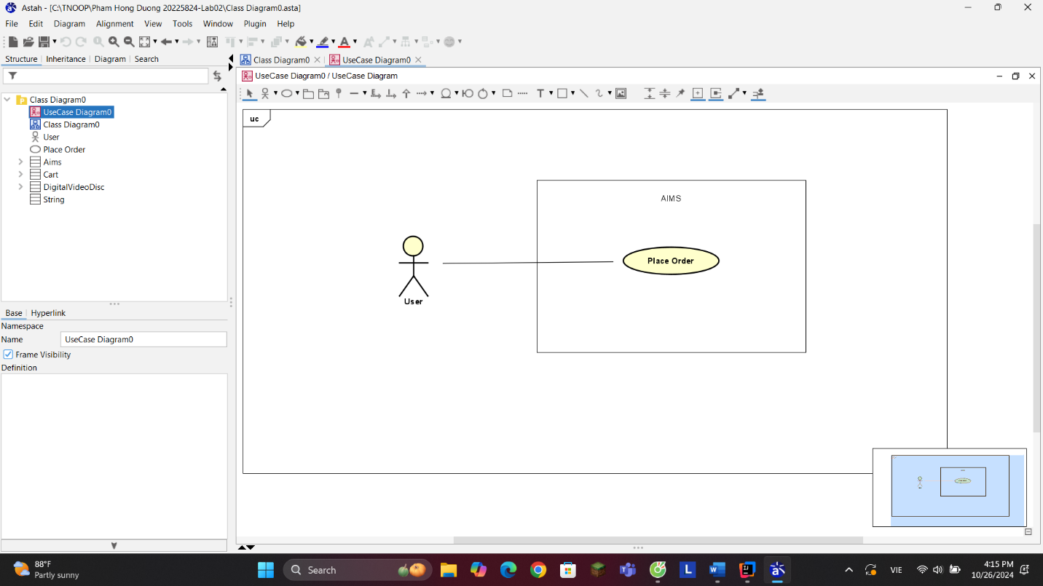

# **2. UML Class Diagram for use cases related to cart management**

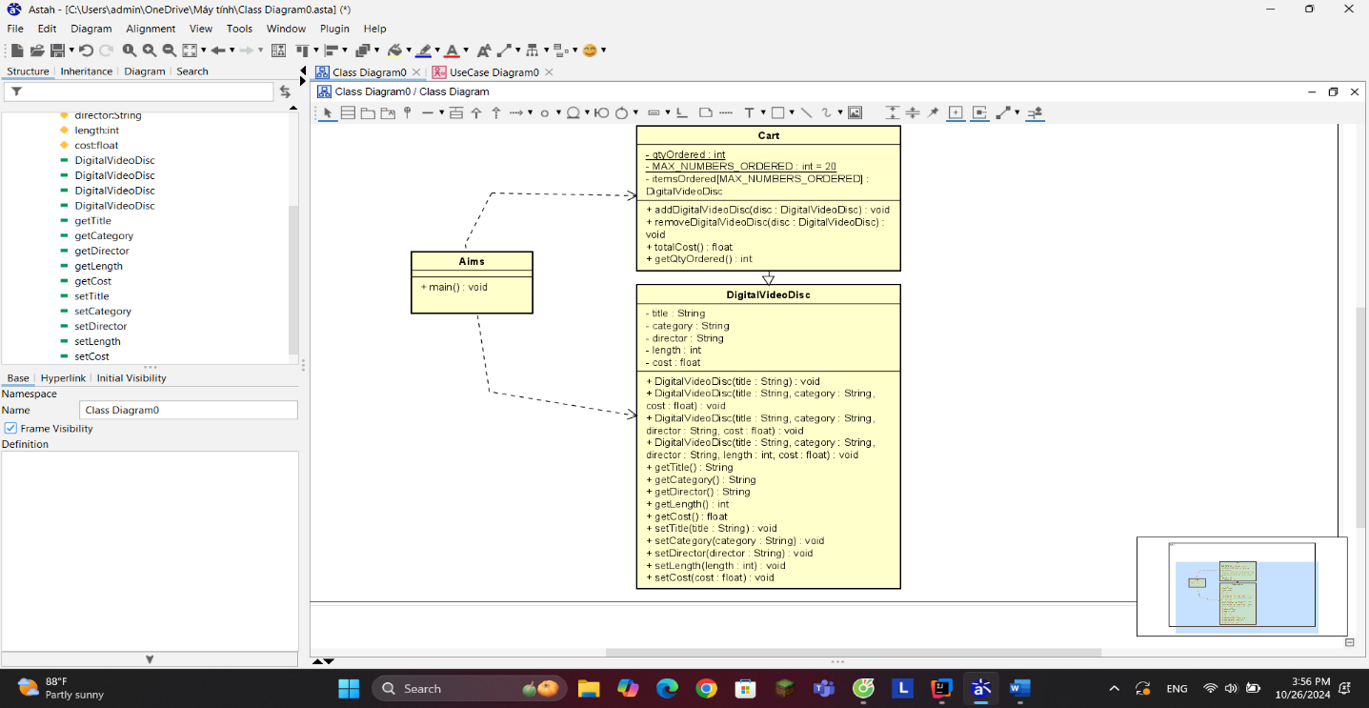

1. **Reading Assignment: When should accessor methods be used?**

**Read the following article and find the best possible answer to the above question: Holub, Allen. “Why getter and setter methods are evil” *JavaWorld*, 5 Sep. 2003,** [**https://www.infoworld.com/article/2073723/why-getter-and-setter-methods-are-evil.html**](https://www.infoworld.com/article/2073723/why-getter-and-setter-methods-are-evil.html)

**You should expand your research to other sources as well. For the response, give a summary of your findings in the form of a mindmap. You can draw this mind map by hand and take a picture of your work or use any online tools. In both cases, the accepted format for the image file is one of the following: .png, .jpg, .jpeg and .pdf.**

**4. If you create a constructor method to build a DVD by title then create a constructor method to build a DVD by category. Does JAVA allow you to do this?**

-> Đúng vậy, Java cho phép bạn có nhiều constructor trong một lớp, một khái niệm được gọi là *nạp chồng constructor*. Điều này có nghĩa là bạn có thể tạo các constructor khác nhau với danh sách tham số duy nhất trong cùng một lớp.